**Lab 10 Part 10**

**View Orders, Order Details**

In this exercise we will functionality to the online shopping project to enable a user to view their list of orders and the details of each order.

**View Orders**

In VS Code open **order/views.py** and copy-paste the following imports:

from django.contrib.auth.mixins import LoginRequiredMixin

from django.views.generic import View

Copy-paste the following class-based view to **order/views.py**:

class orderHistory(LoginRequiredMixin, View):

    def get (self, request):

        if request.user.is_authenticated:

            email = str(request.user.email)

            order_details = Order.objects.filter(emailAddress=email)

        return render(request, 'order/orders_list.html', {'order_details': order_details})

Note the user of the mixin here to ensure that only logged in users can view their orders.

To view orders for a certain customer, we use the email address as shown here on lines 17 & 18. When a user signs up for a new account they will need to supply an email address & this email address will be used to match an order with a customer.

The email is already specified in **accounts/forms.py** as shown below:

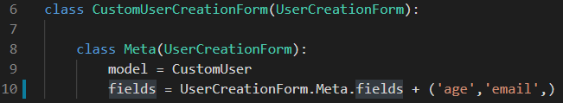

Create a new folder inside the **order/templates** folder called **order** & inside this folder create a new file called **orders_list.html**. Copy in the following code:

**orders_list.html**

{% extends "base.html" %}

{% load static %}

{% block title %}

    Order History - Perfect Cushion Store

{% endblock %}

{% block content %}

    <div>

        <div class="text-center">

            <br>

            <h1 class="text-center my_title">Order History</h1>

            <br>

            {% if order_details %}

            <table class="table table-striped">

                <thead>

                    <tr>

                        <th>Order Number</th>

                        <th>Order Date</th>

                        <th>Total Amount</th>

                        <th>Status</th>

                        <th>Action</th>

                    </tr>

                </thead>

                <tbody>

                    {% for order in order_details %}

                    <tr>

                        <td>{{ order.id }}</td>

                        <td>{{ order.created|date:"d M Y" }}</td>

                        <td>{{ order.total }}</td>

                        <td><i class="fas fa-check"></i>&nbsp;Complete</td>

                        <td><a href="">View order</a></td>

                    </tr>

                    {% endfor %}

                </tbody>

            </table>

            {% else %}

            <p>You have not placed any orders yet.<br><br><a href="{% url 'shop:all_products' %}"

                                                           class="btn btn-secondary">Continue shopping</a></p>

            {% endif %}

        </div>

    </div>

    <br>

    <br>

{% endblock %}

Open the **order**/**urls.py** file and add in the following code:

Run the server and sign up for a new account on the website. Make some purchases and you can then access the order history page by typing in the following url:<http://127.0.0.1:8080/order/history/>

If you have orders in your account, you will see them as shown below:

Now we want to add a link in our top nav bar for the Order History. Open **top-navbar.html** and copy-paste the following block of code to the location shown below:

                <div class="dropdown-menu dropdown-menu-right">

                    <a href="{% url 'order:order_history' %}" class="dropdown-item">Order History</a>

                </div>

Save the project and refresh the homepage. In the topnav bar you will see a drop-down menu with a link to Order History.

**View Order Detail**

Now we will implement a view function to get the order detail of an order for a customer. Add the following import to **order/views.py**:

Copy-paste the following code to **order/views.py**:

class orderDetail(LoginRequiredMixin, View):

    def get(self, request, order_id):

        if request.user.is_authenticated:

            email = str(request.user.email)

            order = Order.objects.get(id=order_id, emailAddress=email)

            order_items = OrderItem.objects.filter(order=order)

        return render(request, 'order/order_detail.html', {'order': order, 'order_items': order_items})

Create a new file inside **order/templates/order** called **order_detail.html**. Copy-paste the following code:

{% extends "base.html" %}

{% load static %}

{% block title %}

Order Details - Perfect Cushion Store

{% endblock %}

{% block content %}

<div>

    <div class="text-center">

        <br>

        <h1 class="text-center my_title">Order Details</h1>

        <br>

        <table class="table table-bordered">

            <tr>

                <td class="text-left" colspan="2">

                    <b>Order: </b>#{{ order.id }}<br>

                    <b>Date: </b>{{ order.created|date:"d M Y" }}<br>

                    <b>Order Total: </b>€{{ order.total }}<br>

                    <b>Order Status: </b><i class="fas fa-check"></i>

                <td class="text-left" colspan="2">

                    <b>Billing Address: </b><br>

                    {{ order.billingName }}<br>

                    {{ order.billingAddress1 }}<br>

                    {{ order.billingCity }}<br>

                    {{ order.billingPostcode }}<br>

                    {{ order.billingCountry }}<br>

                </td>

            </tr>

            <tr>

                <td><b>Product Description</b></td>

                <td><b>Qty</b></td>

                <td><b>Unit Price</b></td>

                <td><b>Sub-Total</b></td>

            </tr>

            {% for item in order_items %}

            <tr>

                <td>{{ item.product }}</td>

                <td>{{ item.quantity }}</td>

                <td>€{{ item.price }}</td>

                <td>€{{ item.sub_total }}</td>

            </tr>

            {% endfor %}

            <tr>

                <td class="text-right" colspan="3"><b>Total</b></td>

                <td>€{{ order.total }}</td>

            </tr>

            <tr>

                <td class="text-right" colspan="3"><b>Total Paid</b></td>

                <td>€{{ order.total }}</td>

            </tr>

            <tr>

                <td class="text-left" colspan="2">

                    <b>Shipping Address: </b><br>

                    {{ order.shippingName }}<br>

                    {{ order.shippingAddress1 }}<br>

                    {{ order.shippingCity }}<br>

                    {{ order.shippingPostcode }}<br>

                    {{ order.shippingCountry }}<br>

                </td>

                <td class="text-left" colspan="2">

                    <b>Payment Details: </b><br>

                    The order #{{ order.id }} has been paid successfully via Stripe.

                </td>

            </tr>

        </table>

    </div>

</div>

{% endblock content %}

Open **order/urls.py** file and add in the following code:

Open **order/templates/order/orders_list.html** and add in a link for the order detail page:



Save your project and view the orders. You can now click on the **View order** link to view the details of an order.

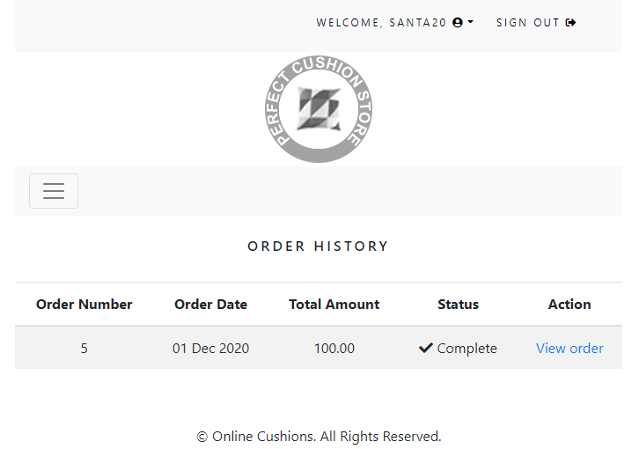

Update your Lab 10 repo with these new changes